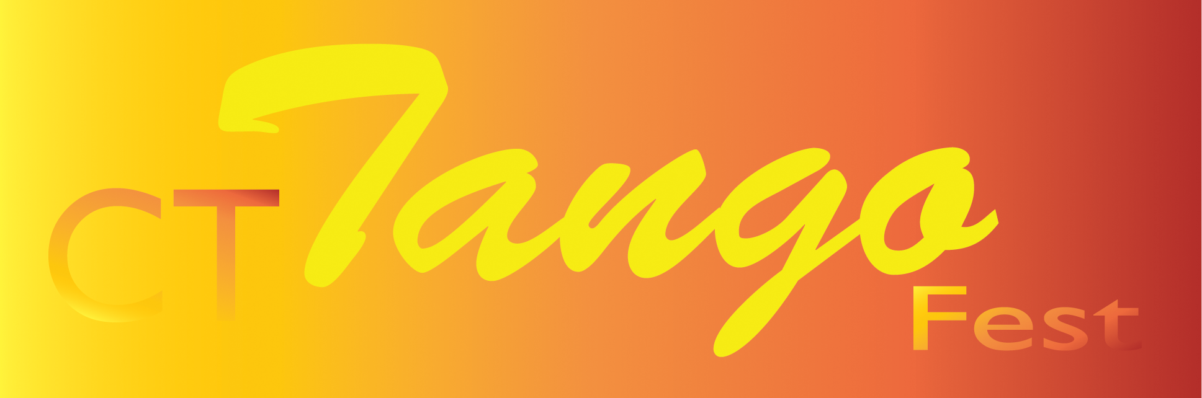  www.CTTangoFest.org | FOR IMMEDIATE RELEASE  February 8, 2017  Press Phone: (203) 543 8099, e-mail: CTTangoFest@gmail.com

Milford Arts Council Presents

Argentine Tango Boot Camp for Beginners
at the CT Tango Weekend 2017

www.CTTangoFest.org

Intensive Argentine Tango Afternoon for beginners at the
Milford Arts Council

Dale Ellison and Jorge “Gem” Duras instructors

DATE: Saturday, March 18, 2017
TIME: 2:30 – 5:30 p.m.
PLACE: Milford Center for the Arts, 40 Railroad Avenue South, Milford CT
REGISTRATION: www.CTTangoFest.org
PRICE: $50 per person
CONTACT FOR PUBLIC/REGISTRATION: (203) 584-4480

Dale Ellison will be visiting from Charleston SC, to join Gem Duras for an intensive weekend of Argentine Tango, in Milford, Norwalk, Danbury, Middletown and Enfield.

The Boot Camp in Milford on Saturday March 18 will be geared towards beginners and less experienced dancers who want to review the fundamentals. During their 3 hours of instruction, Dale and Gem will present the basic figures, turns and signature patterns of Argentine tango such as "ochos" and 'ganchos". Singles are welcome, enrollment is limited, pre-registration recommended.
The Milford activities will continue the same night at the Milford Center for the Arts with a tango social –known in tango circles as “Milonga” with a performance with Dale and Gem. The activities will continue with intermediate and advanced workshops in Norwalk the following day.
Milford Arts Council offers weekly tango classes on Mondays with instructor Gem Duras as part of its dance program.

Dale Ellison, known in Buenos Aires as Delia, has been dancing Argentine tango for more than 22 years, and teaching for more than 14. She has developed a reputation as a dynamic Argentine Tango teacher and performer in salon, milonguero, nuevo and performance styles of tango. Originally a San Francisco resident, Dale received her tango training from the stars of the famous show “Forever Tango” most notably Carlos Gavito and Marcela Duran. Initially a salsa dancer and club style salsa instructor, Dale was drawn to tango for its sensuality and passion, later winning the first prize in the first San Francisco Tango Competition in 1998. She has traveled to Buenos Aires numerous times to study with Gustavo Naveira, Osvaldo Zotto, Oscar Mandagaran, Chicho Frumboli, Geraldine Rojas, Graciela Gonzales, Marcela Duran, and women's technique with Lorena Ermocida. After teaching in CT for five years with Gem Duras, Dale Ellison moved to Charleston SC, where she teaches and runs tango activities as the director of Tango Rojo. | 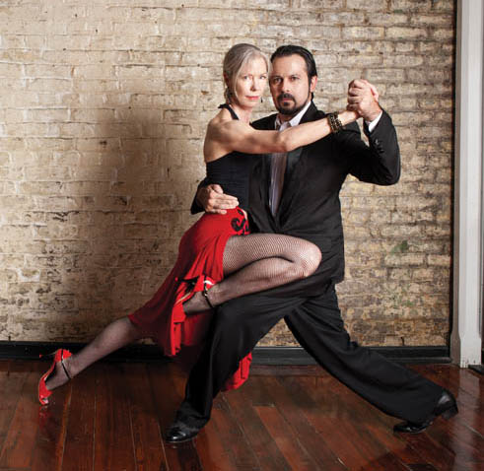  Dale Ellison and Gem Duras  Photo: Gregg Carr
Gem Duras has been dancing tango for 22 years and teaching full time for 14. In 1990's he studied with the original cast members of the famous show Forever Tango, in particular the legendary Carlos Gavito. He then visited Buenos Aires numerous times to study advanced technique, ballet and stage tango with younger Forever Tango stars Francisco Forquera and Jesus Velazquez, receiving his tango training certificate. Over many years he became familiar with the styles of such important and diverse dancers as Mariano "Chicho" Frumboli, Gustavo Naveira, Susana Miller, Javier Rodriguez, Osvaldo Zotto, Norberto "Pulpo" Esbrez, Geraldine Rojas, Carlos Rivarola, Juan Carlos Copes, Dana Frigoli and Milena Plebs. As a result he is able to teach and guide the students in various tango styles such as Salon, Milonguero, Nuevo and beyond. He holds weekly classes throughout Connecticut and regularly travels to Buenos Aires to follow the current trends in tango. With Tango Sueño co-founder Dale Ellison, he organizes and directs the Connecticut Tango Festival.

###
Not for publication: Please visit http://www.cttangofest.org/press_weekend.html for high-resolution versions of this and other photos for print publication

